Why JSX And Babel ?

# Why JSX

Basically, writing react element using react.createElement() is so difficult and lengthy , So that’s why we use JSX.

const card = *React*.createElement(

    "div",

    {

        id: "card",

        style: {

            width: "300px",

            height: "300px",

            borderRadius: "10px",

            backgroundColor: "#d079f5",

            display: "flex",

            flexDirection: "column",

            padding: "20px",

            margin: "120px auto",

        },

    },

    [

*React*.createElement(

            "h1",

            {

                key: 1,

            },

            "React.createElement()"

        ),

*React*.createElement(

            "p",

            {

                key: 2,

            },

            "👋 Hello, I'm Talha Ali 🎓 Software Engineering Student @ Superior University 📚 Currently in my 4th Semester Happy coding! 🚀 👋 Hello, I'm Talha Ali 🎓 Software Engineering Student @ Superior University 📚 Currently in my 4th Semester Happy coding! 🚀  "

        ),

*React*.createElement(

            "button",

            {

                key: 3,

                style: {

                    margin: "0px auto",

                    width: "40%",

                },

            },

            "Contact Us"

        ),

    ]

);

const root = ReactDOM.createRoot(document.querySelector("#root"));

root.render(card);

normal react is so lengthy

# JSX

Enable us to write code html code in JS

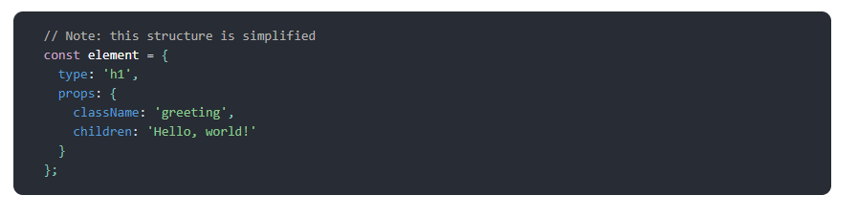

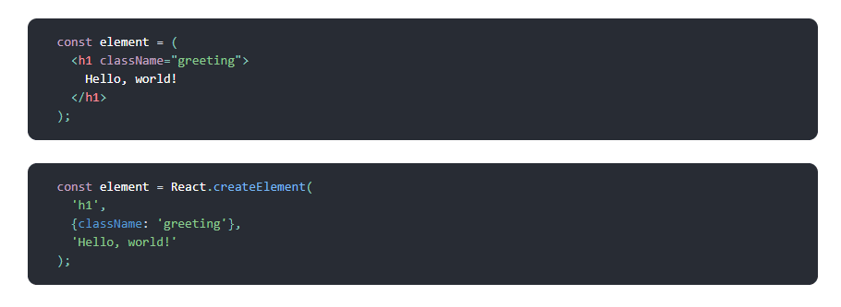

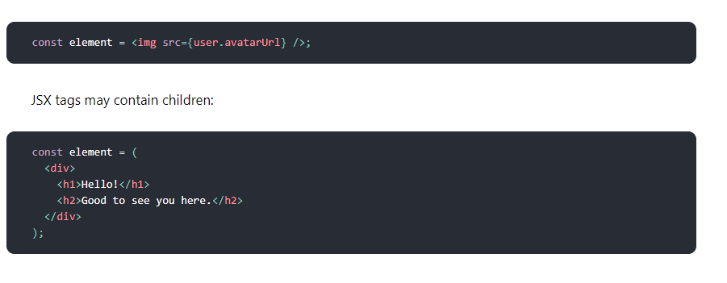

**As you see Code become short and easy to use.**

# Why Babel

Babel is basically the compiler for JavaScript which Convert JSX to Normal Js

